Job Application Tracking System

## 1 INTRODUCTION

## OVERVIEW

A job application tracking system is software for recruiters and employers to track candidates throughout the recruiting and hiring process. This software can come equipped with capabilities ranging from simple database functionality to a full-service suite of tools that makes it easy for business of any size to filter, manage and analyze candidates.

### PURPOSE

The system helps HR organize, screen, and categorize applicants who fit for the position and discard those who fit for the position and discard those who do not fit. Source and attract qualified candidates. Some organizations lack the reach to connect with top job seekers or to as a cast a wide enough net in the marketplace. Increase candidate engagement. Improve efficiency and lower costs. Remain competitive. Optimize the onboarding process. An Application tracking system creates opportunities to automate manual processes, increase visibility into the hiring cycle for entire team and increase opportunities for communication throughout the candidate journey.

## 2 PROBLEM DEFINITION &DESIGN THINKING

### 2.1 EMPATHY MAP

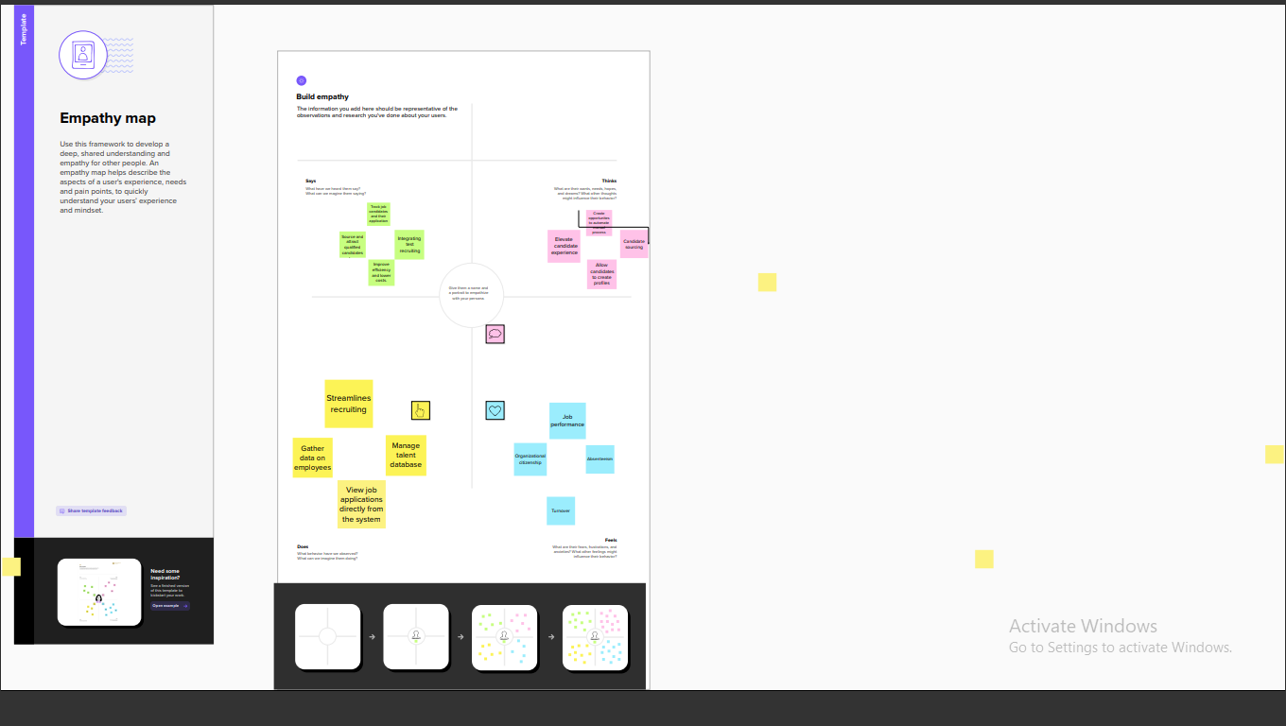

### IDEATION & BRAINSTORMING MAP

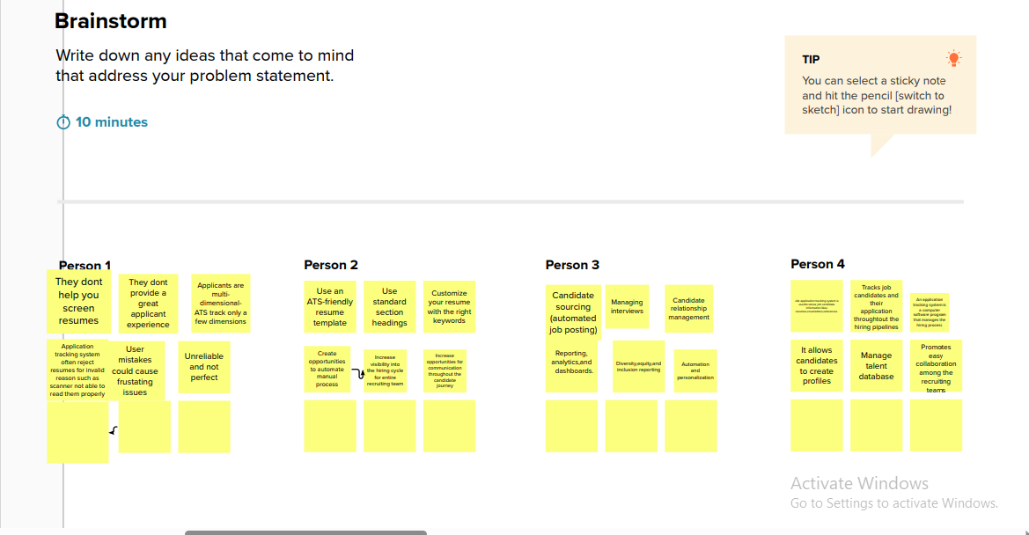

## 3 RESULT

## 3.1DATA MODEL:

|  |  |
| --- | --- |
| OBJECT NAME | FIELD IN THE OBJECT |
| Standard object | |  |  | | --- | --- | | Field label | Data type | | Recruiter | Auto number | |
| Custom object | |  |  | | --- | --- | | Field label | Data type | | candidate | Job application | |

## 3.2ACTIVITY & SCREENSHOT

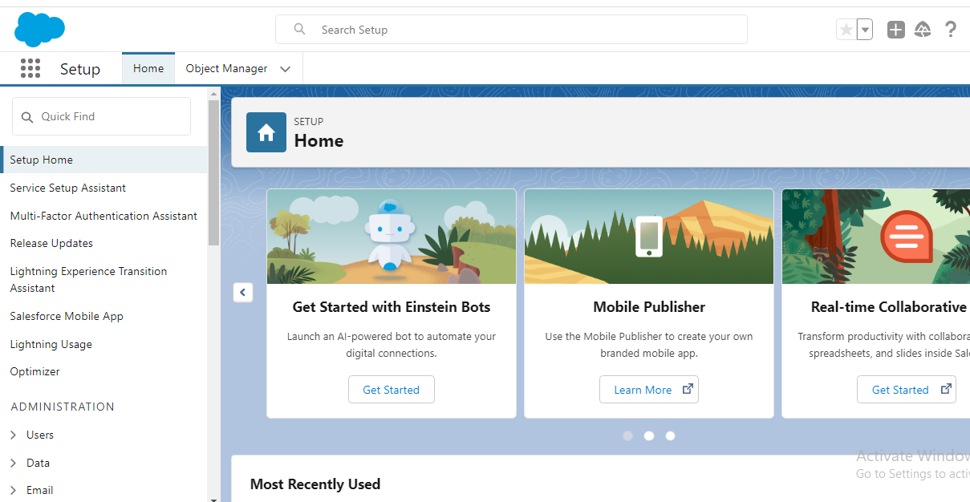

## ACTIVITY 1

## OBJECT

## CREATE A CUSTOM OBJECT FOR RECRUITER:

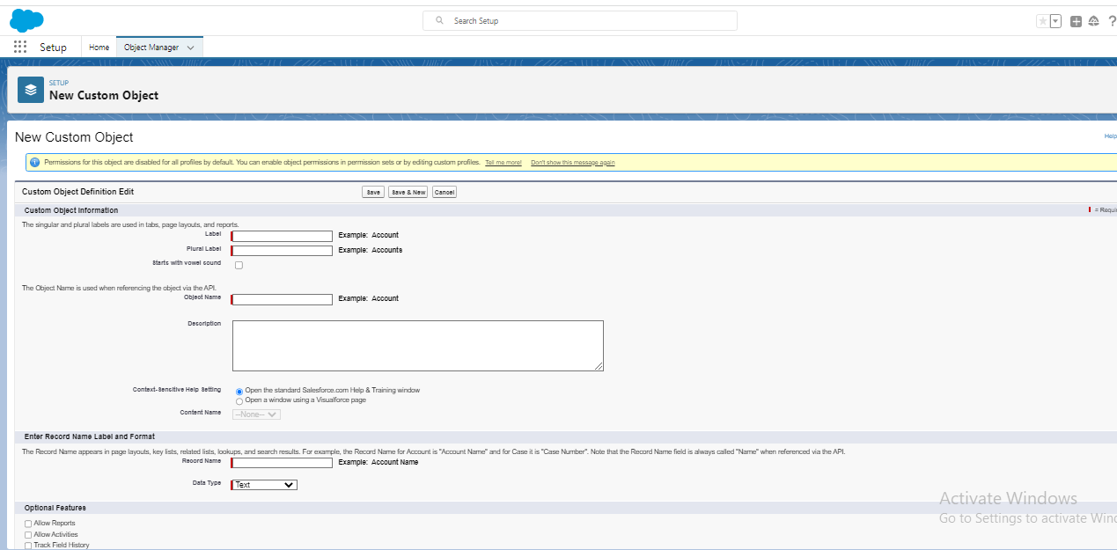

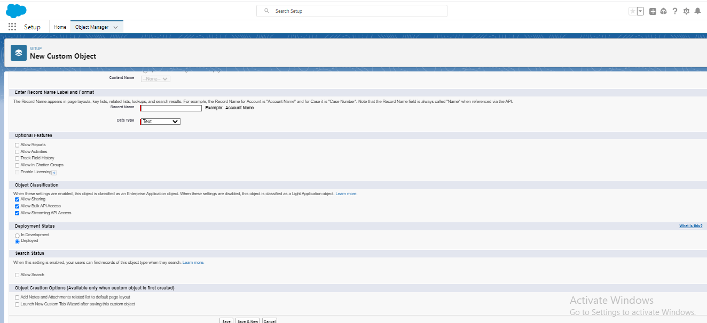

## ACTIVITY 2

1. Create a Jobs, candidate, Job application, object and tab.

## FIELDS

## ACTIVITY 1

## Create the custom fields:

1. Click the object manager tab select the object for which you have to create the fields and relationships.

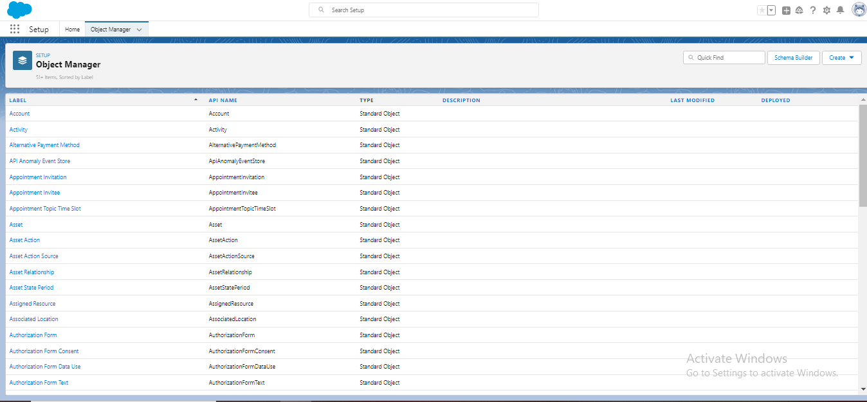

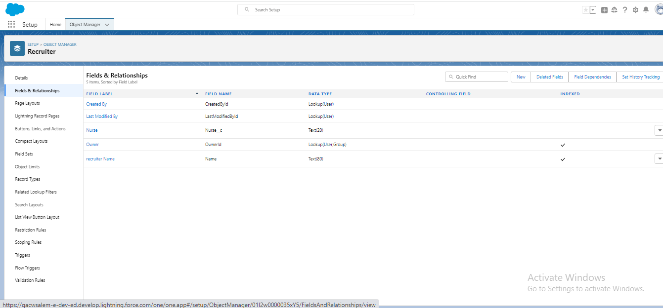

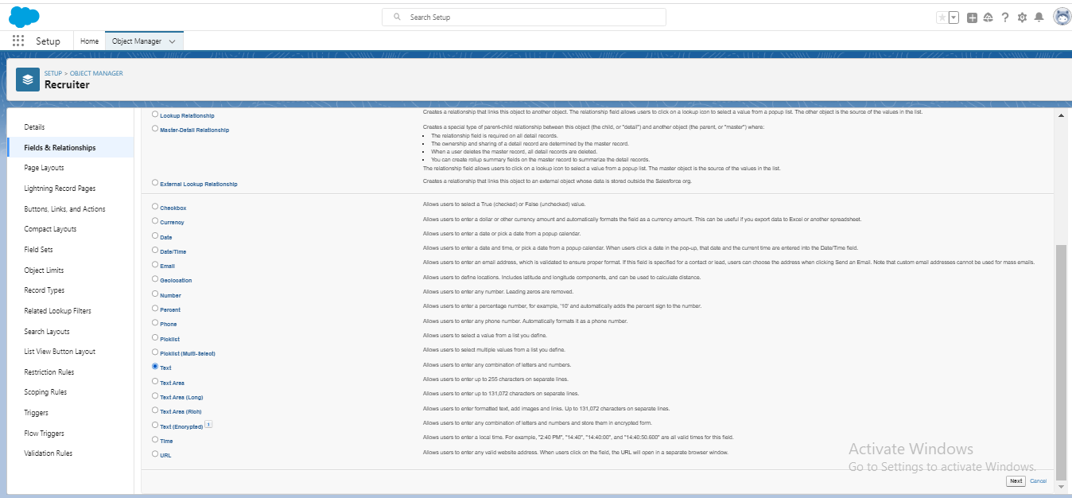

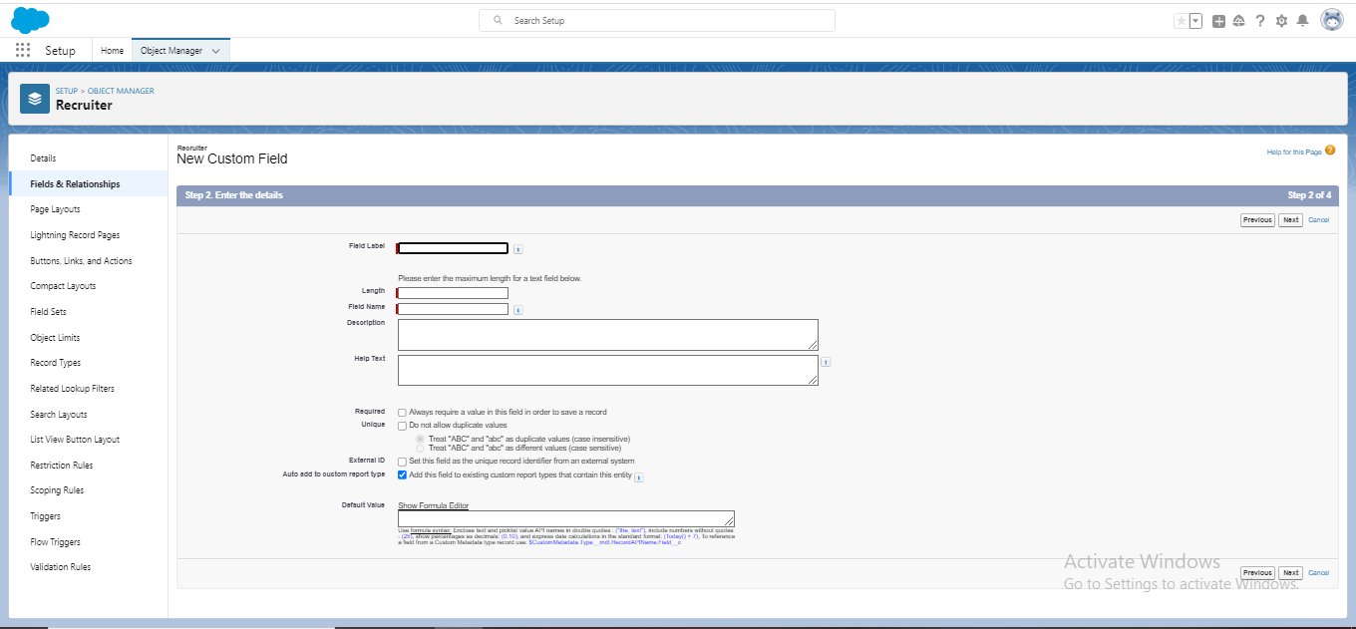

## ACTIVITY 2:

## Creation of master-detail relationship:

1.From setup go to object manager.

# 

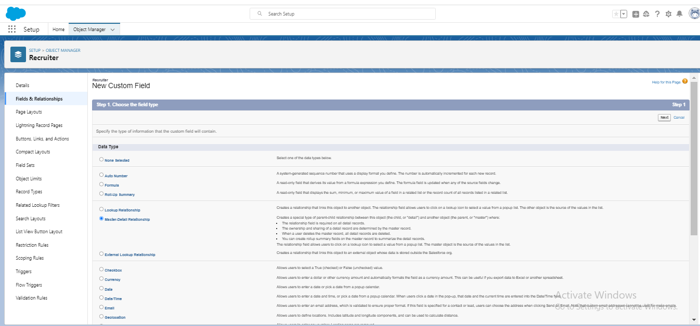

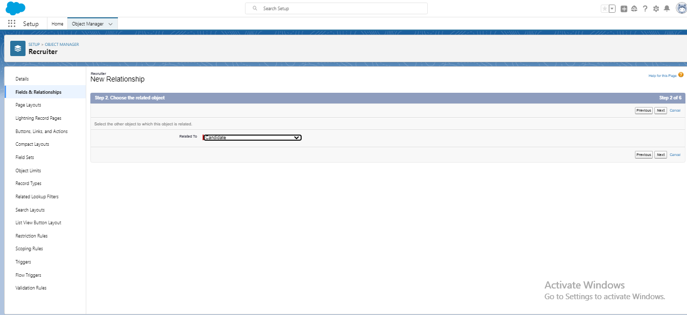

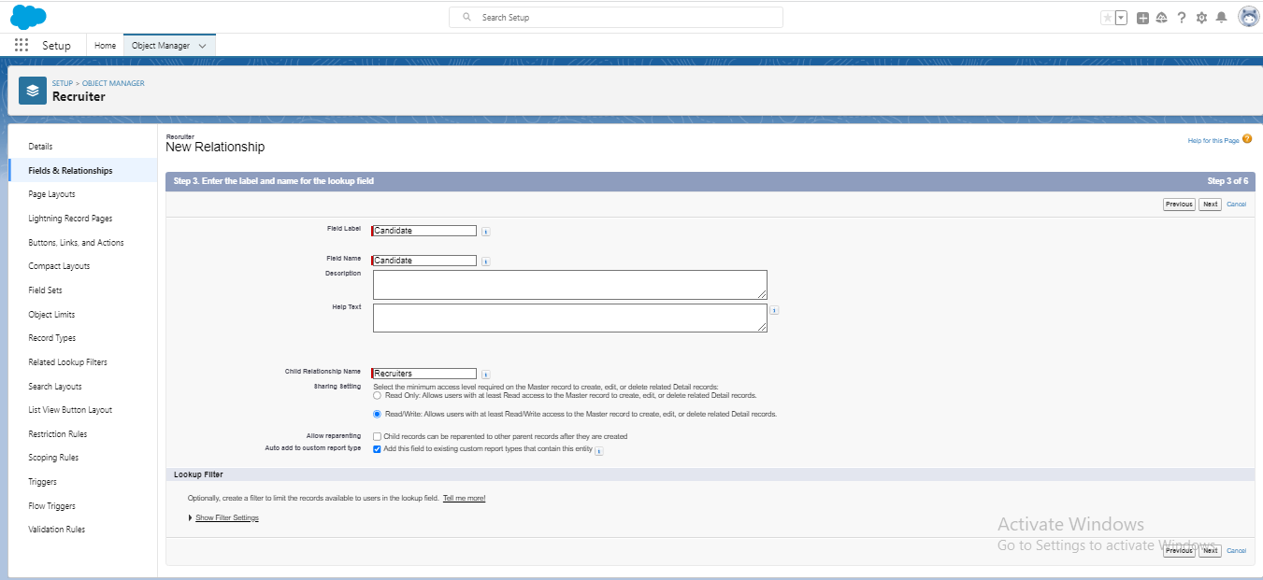

### ACTIVITY 3:

### Create new custom field:



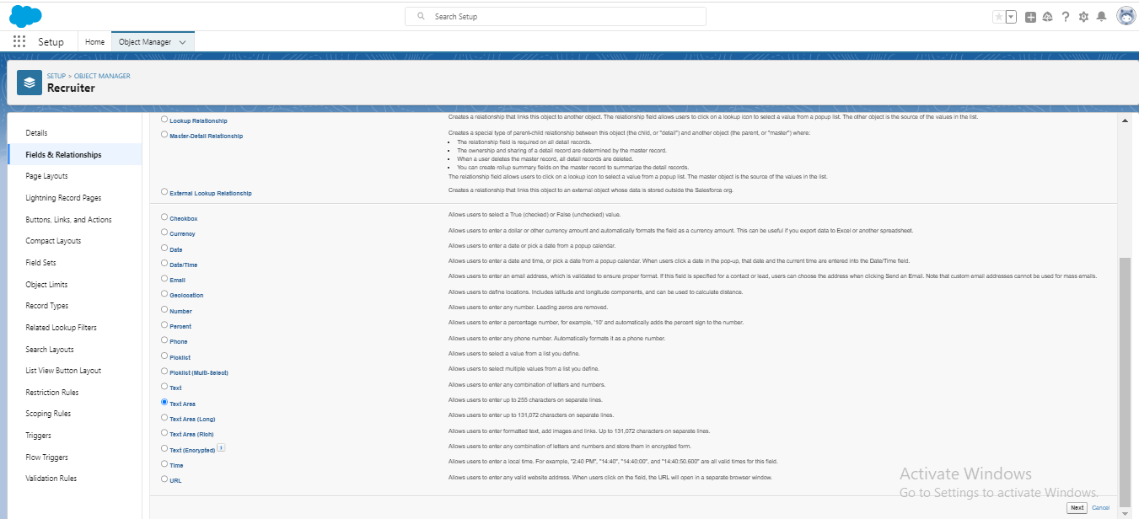

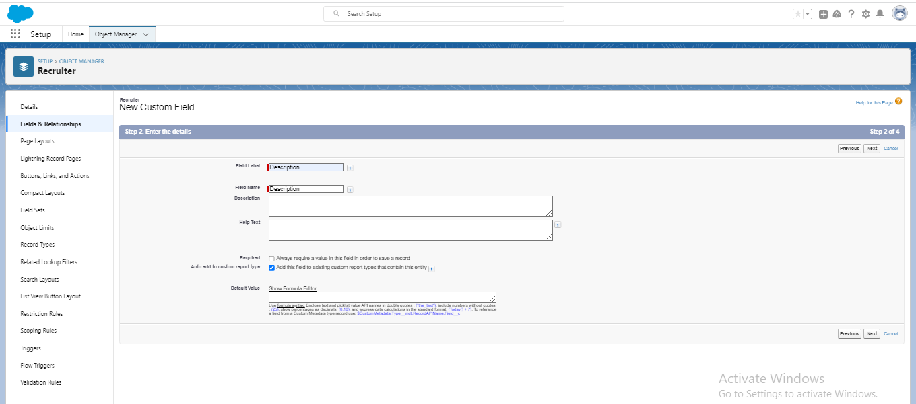

### ACTIVITY 4

### Create a new custom field:





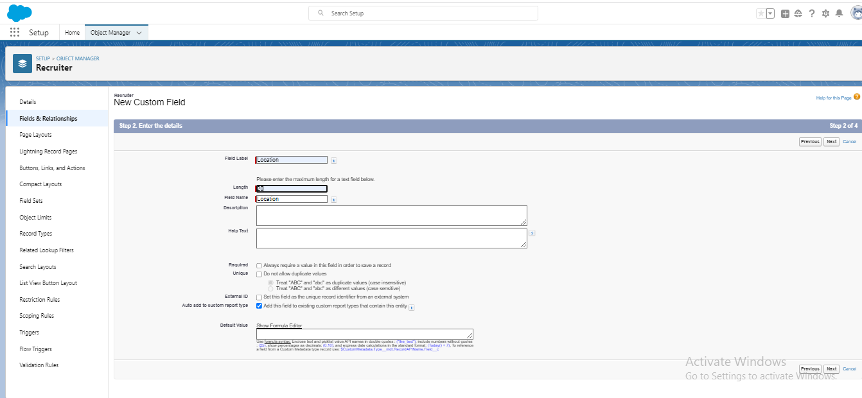

## TAB:

### ACTIVITY 1

### Create tab:

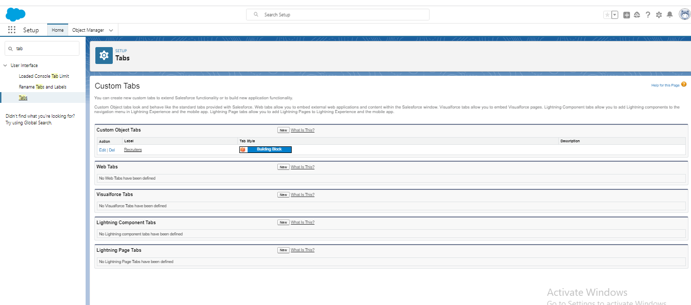

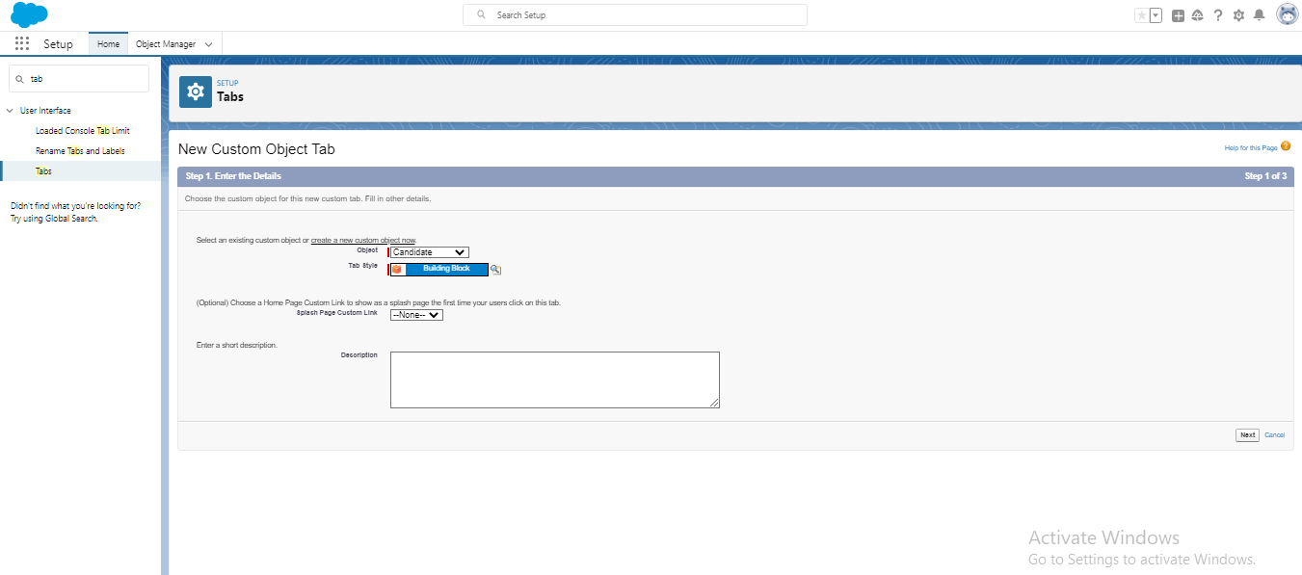

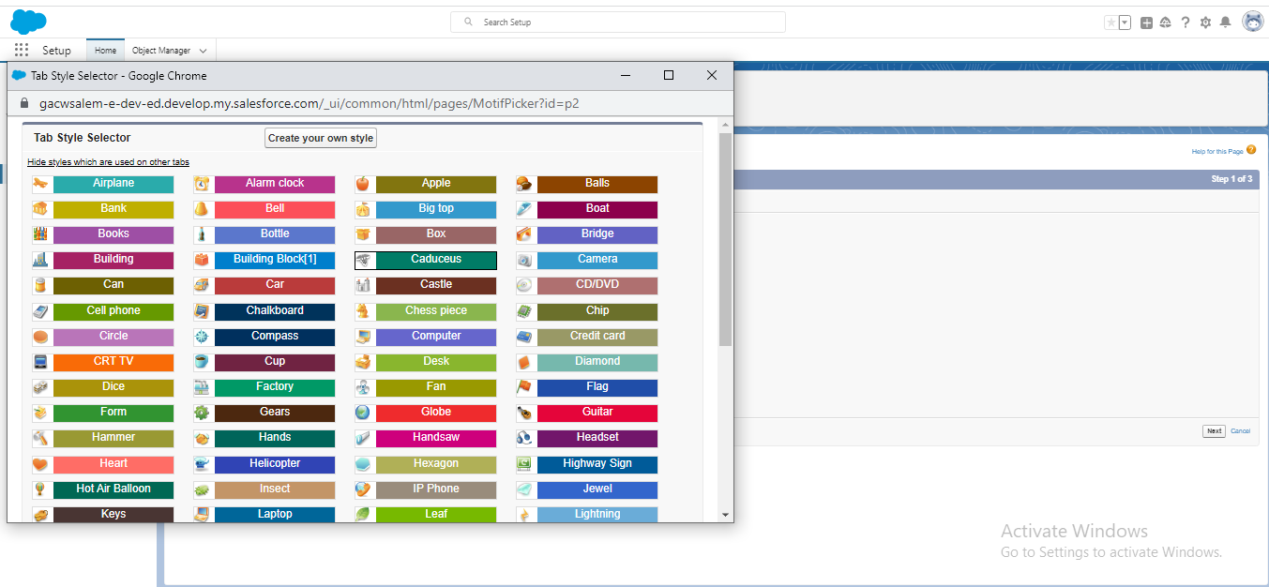

## PROFILE:

### ACTIVITY 1:

### Create Custom profile:

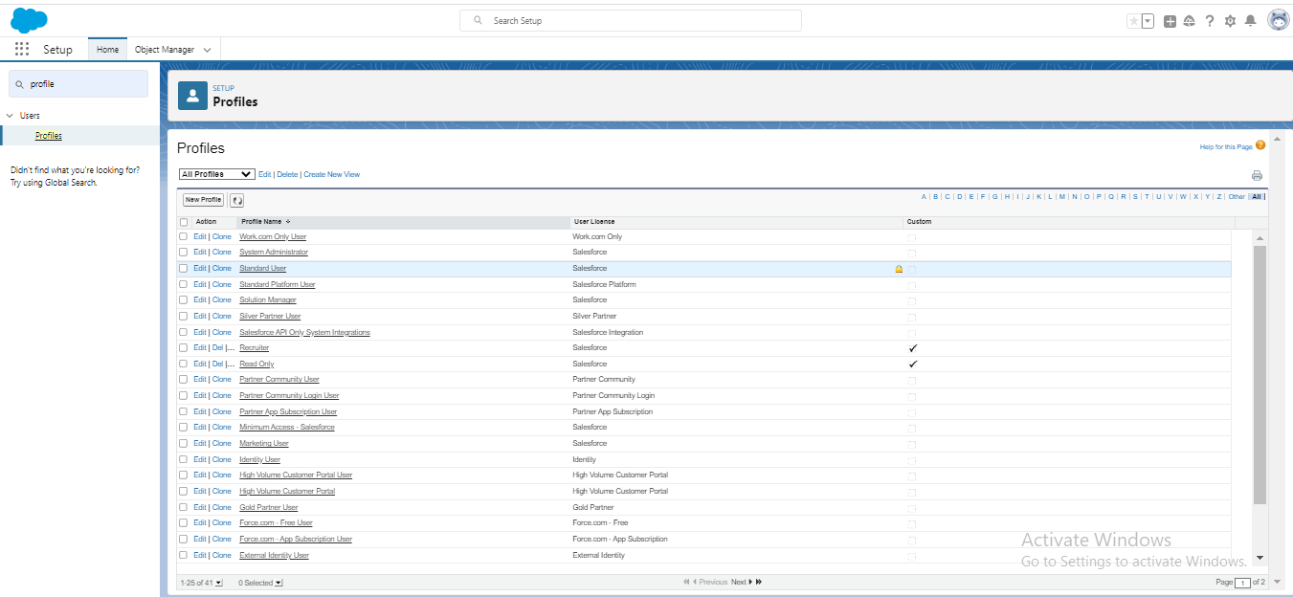

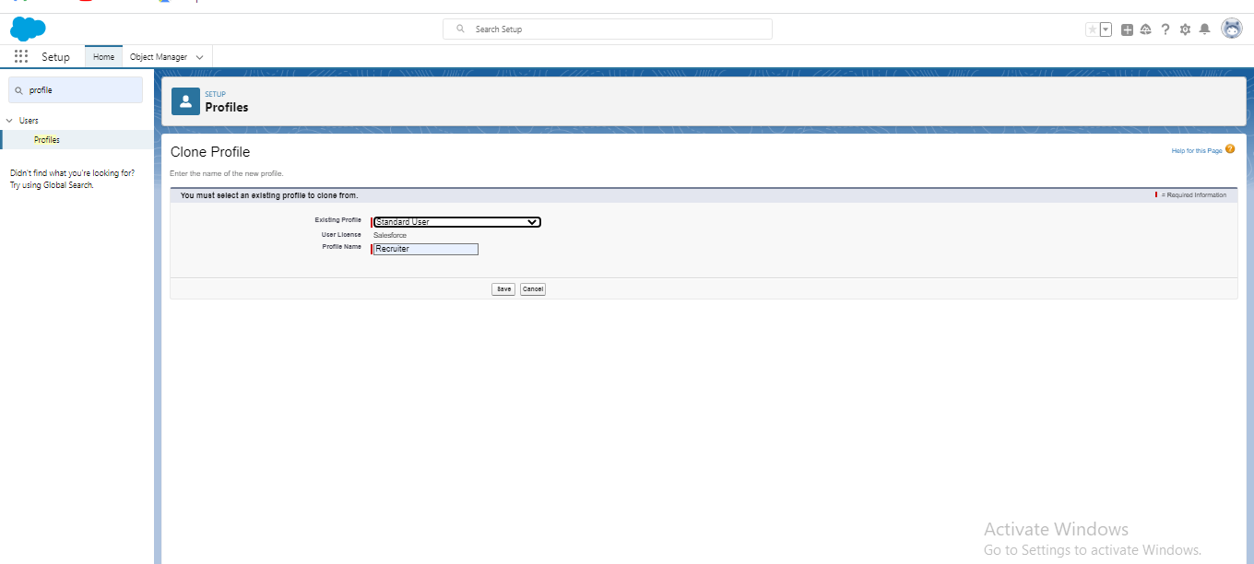

### ACTIVITY 2:

Create a profile with the profile name as “Sales manager”





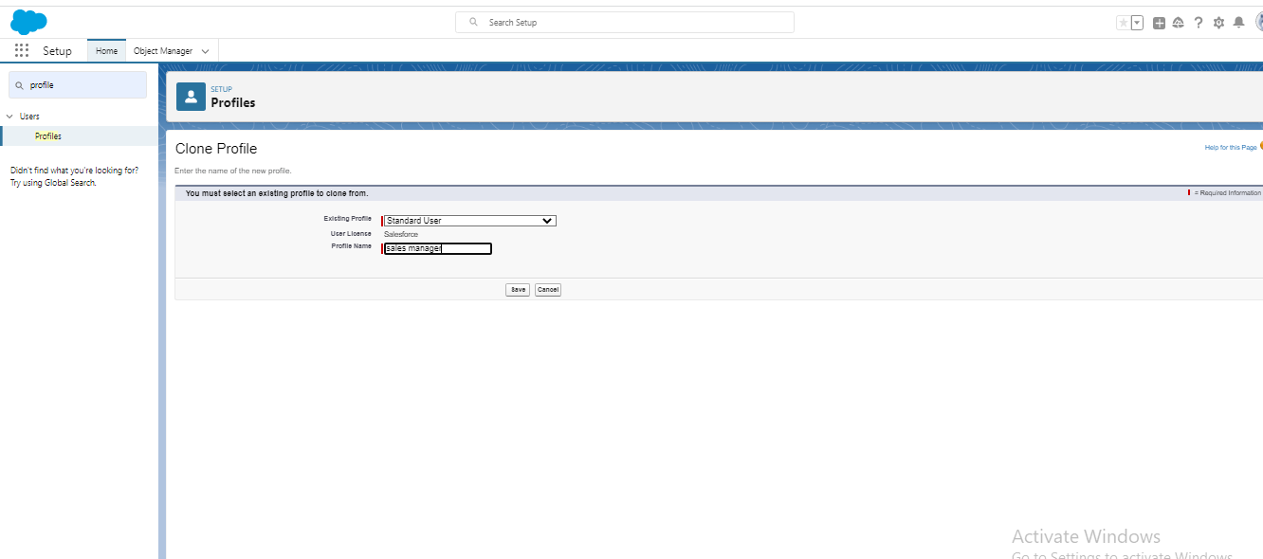

## USER

### ACTIVITY 1:

### To create a user:

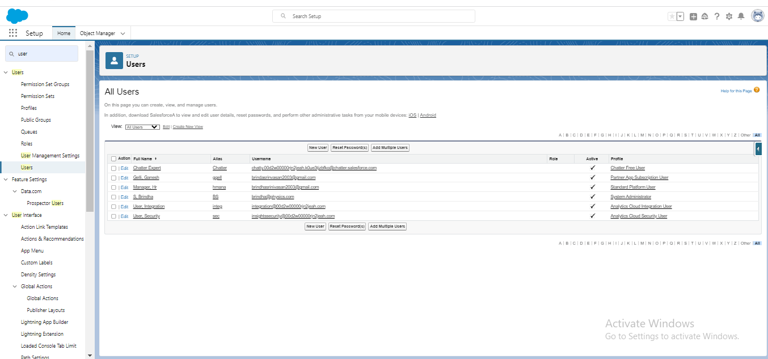

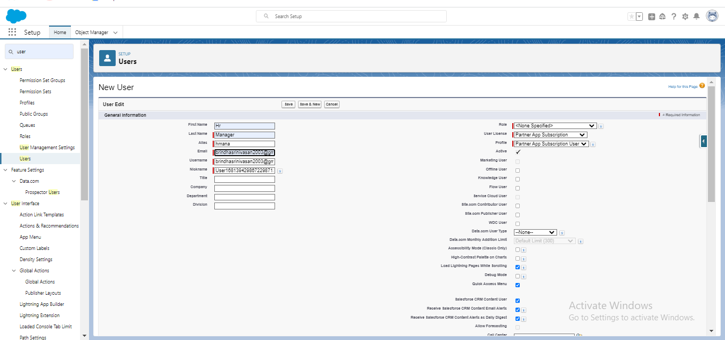

### ACTIVITY 2:

Create a user with a username as “Ganesh Gelli”, and assign him as the sales manager profile.



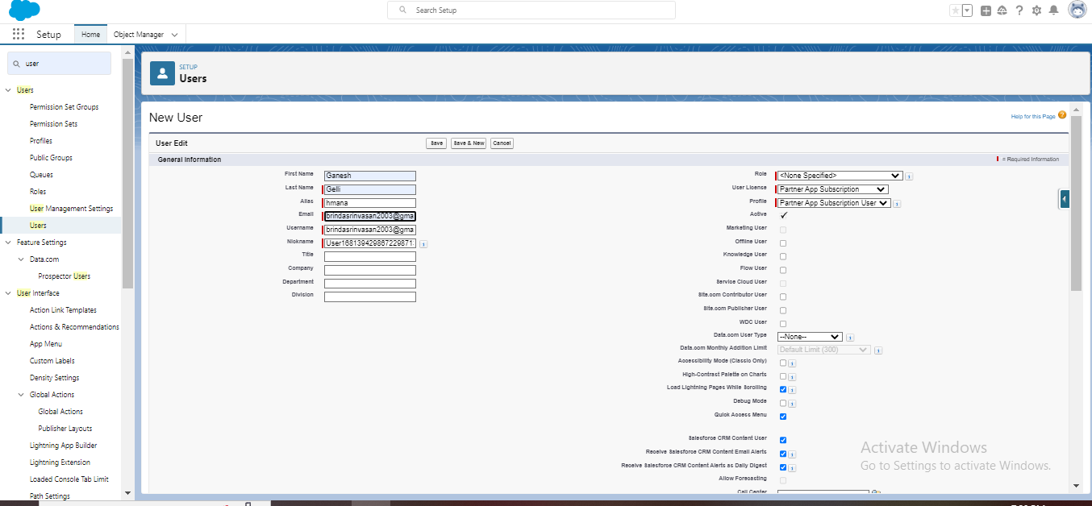

## SHARING RULES

### ACTIVITY 1:

### Create a sharing rule:

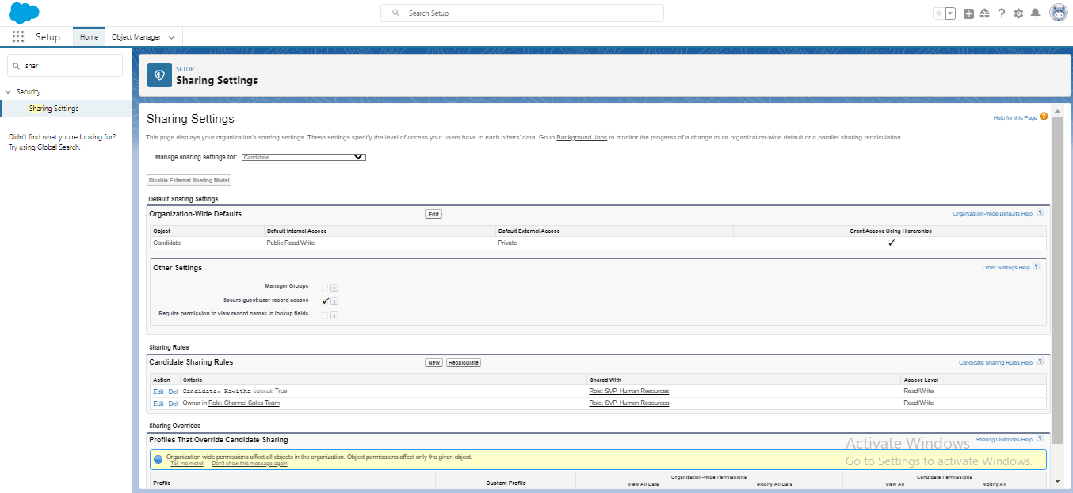

## 

## ACTIVITY 2:



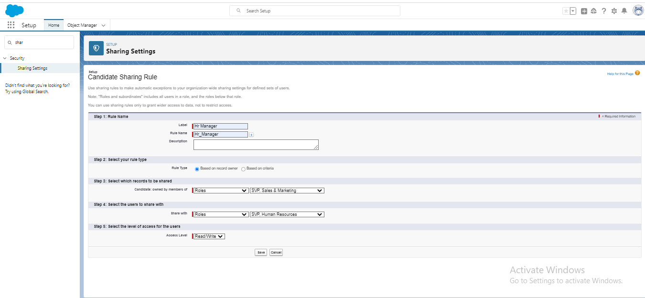

## REPORTS

### ACTIVITY 1:

### Create a report:

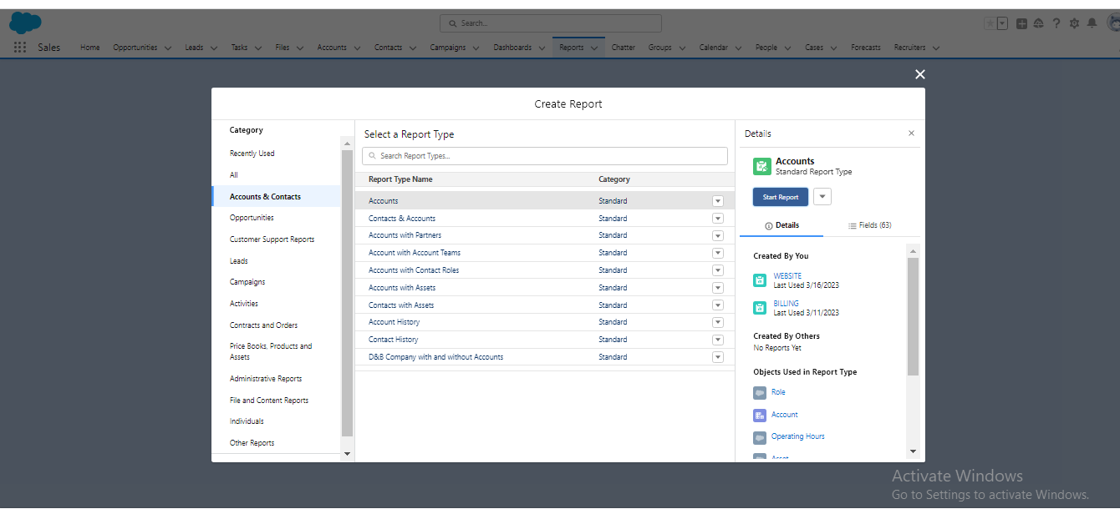

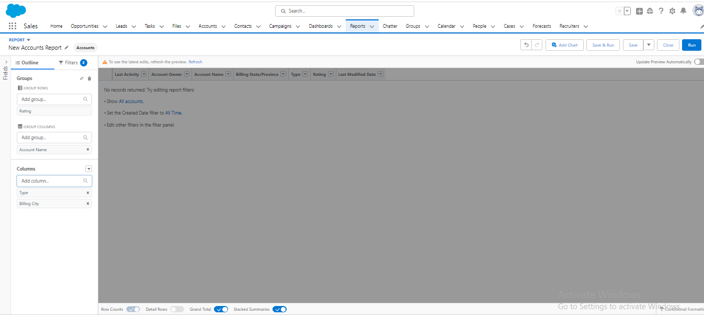

## ACTIVITY 2:



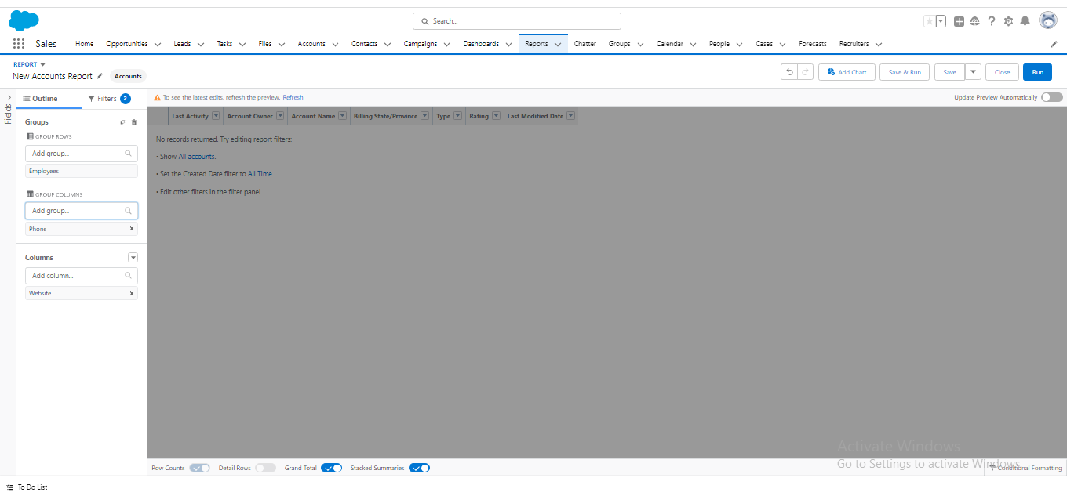

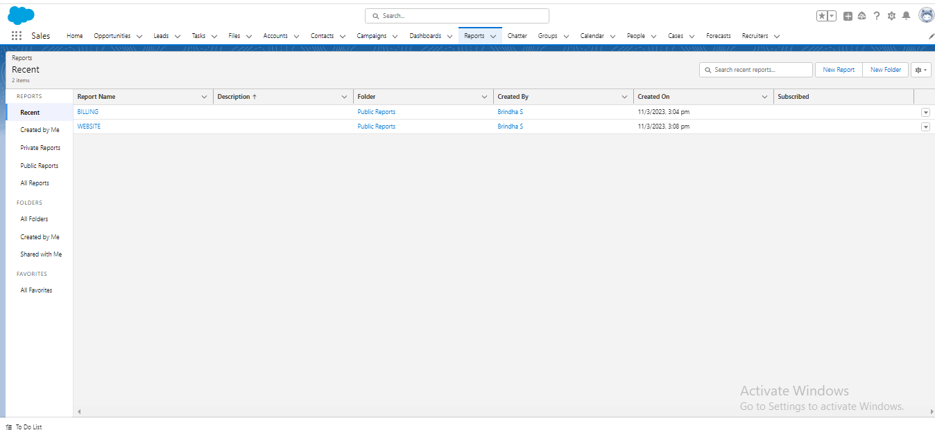

## 4Trailhead profile public URL

Team Lead: https://trailblazer.me/id/brins11]]

Team Member 1-https://trailblazer.me/id/ssujithras

Team Member 2-https://trailblazer.me/id/kalamelu

Team Member3-https://trailblazer.me/id/punim4

## 5 ADVANTAGES & DISADVANTAGES:

## ADVANTAGES

1. It saves a lot of time compared to conventional application processing and hiring tem for both employer & the agency.

2. Posts jobs on multiple job boards.

3. Better overview of applications.

4. It enabling you to focus more on tasks that truly require your attention rather than spending manual resources on routine, mundane tasks.

5. It improves the quality of hire.

## DISADVANTAGES:

1. Automatic elimination of resumes that software cannot recognize and internet is another drawback.

2. They are open to manipulation.

3. A Disadvantage of this ATS is missing qualified applicants due to wrong keyword selection.

4. Missing out on potential great hires and great pipeline talent when resumes are eliminated.

5. Misread resumes in PDF format.

## 6 APPLICATIONS:

Access to multiple job boards and the ability to manage all applications in a centralized location. Increase in productivity and efficiency when hiring –particular at scale. Better candidate experience through faster scheduling and communication –especially in remote and hybrid work environments. Improved employer brand that attracts great candidates. Easier compliance with laws related to recruitment.

## 7CONCLUSION:

Job application tracking system for recruiters is a very effective hiring solution that most of the successful recruiters utilize. Because without it, there is a good chance that your process of moving applicants through different stages can become very difficult.

## 8 FUTURESCOPE:

The world knows that applicant tracking systems made their way into the recruitment domain just a few years ago. According to recently released survey report, the majority of staffing firms worldwide will opt for an ATS by the end of year to improve the overall talent acquisition efficacy, in this scope of future of ATS definitely looks bright.